**Chapter 3**

**METHODOLOGY**

This chapter contains the project design, project development, operation and testing procedure, and evaluation procedure.

**Project Design**

The project is designed to make a queuing system using QR code. The queuing system includes allowing companies to post configurable initial setup of transactions, generating of QR code for customer’s queue, providing a real-time transaction, and providing notification for customers. The customer will choose what type of transaction he/she would like to make in a particular company. The customer will be able to see the estimated time per transaction as well as the counter or window managing the transaction. Then, he/she will be given a QR code for their queue. Next, the customer will be notified 1 hour before, 30 minutes before, 10 minutes before, 2 minutes before and when it is his/her turn.

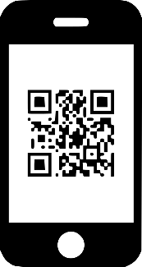

QR CODE SCANNER

Process Data

Data Transmission

USER

Data Transmission

ANDROID PHONE

Data Transmission



WEBSITE

DATABASE

Data Transmission

*Figure 2.* Block Diagram

Figure 2 represents the Block Diagram of the system. The user will register to the android application to schedule a transaction. The information that the user will give will be stored in the database. A QR code will be generated for the user’s queue. The user will go to the establishment to the specific time he/she scheduled then the user will got to his/her designated window and he/she will be ask to scan the QR code. After scanning the QR code, the person in charge on that window will see the customer’s information. The customer will be notified 1 hour before, 30 minutes before, 10 minutes before, 2 minutes before and if it his/her turn. The person in charge on the window will also be able to notify the customer. The company uses the website to register. The company will add transaction accounts that will be used by the window. All the information that the company will give will also be stored on the database.

Notification

Window

Customer Information

Company

Company

Information

QR Code

0

**Android-based Queuing System Using QR Code**

Transaction

Information

Customer

Information

Transaction

Information

Notification

Transaction

Information

Notification Reply

Generated

QR Code

Company

Information

Schedule Transaction

Customer

Customer

Information

Notification Reply

*Figure 3.* Context Diagram of the System

Figure 3 shows Context Diagram of the system. The customer will input his/her information to register. The customer will be able to see the list of all the companies and as well as their information. After choosing what company he/she would like to have a transaction, the customer will be able to see the list of all available transactions in that company and he/she will be able to schedule the time of his/her transaction. After scheduling a transaction, the customer will be able to see the generated QR code which he/she will use for his/her queue. The customer will be notified 1 hour before, 30 minutes before, 10 minutes before, 2 minutes before and when it is his/her turn where the customer will be given a choice if he/she can go or not which will be sent to the window. The person in charge on the window can also notify the customer. The company must also input its information to be able to register. The company will be able to add transactions that will be used by the person in charge on that window. The company will be able to see all the customer that made transactions to their company. The person in charge of the window will be able to see the information of the transaction on that window and as well as the information of the all the customer on that day.

1.0

User Transaction

User Transaction

View Users

Transaction Info

Transaction Info

Transaction Type

Manage Transaction

Transaction Type

Transaction

Transaction Type

Company

D1

D2

2.0

D3

User_transac

User Info

D4

Users

1.0

QR Code

User Transaction

User Transaction

User Transaction

User_transac

View Pending or Past Transaction

User Transaction

Transaction Info

Transaction Info

Transactions

Company Info

Company Info

Customer

Make Transaction

Transaction

Company

User Transaction

Manage Users

Users Info

User Transaction

Users

Window

QR Code

User_transac

Manage Queue

User Transaction

D1

D2

2.0

Notification

User Transaction

1.0

D1

D3

D2

2.0

*Figure 4*. Data Flow Diagram

The Figure 4 shows the data flow diagram of the system. To manage the transaction, the company must first add transaction types. After adding different transaction types, the company can now create transaction accounts. The company will input the transaction accounts’ information and its transaction type. To be able for the company to see its users, the system will get the information of those users who made transaction on that company. For the window, to manage the queue, the person in charge on the window should scan the QR code of the customer. After scanning the QR code, the system will get the information of the that user as well as its transaction’s information. The person in charge on the window can view the transactions and information of users that made a transaction on that day, and can also notify the user. To be able for the customer to make a transaction, the system will send the list of all companies as well as their information and list of available transactions. The customer then will choose the transaction he/she wants to make on that company and he/she will the time of his/her transaction from the list of available schedules. The customer can view its pending and past transaction as well as the generated QR code of the transaction.

**Use Case Diagram**

The use case shows the roles of each user in the system. There are four actors in the developed system, the administrator, company, window, and the customer.

<<include>>

<<include>>

<<include>>

<<include>>

**Administrator**

*Figure 5.* Administrator Use Case Diagram

Figure 5 shows the Administrator Use Case Diagram of the system. It consists of the main processes that the admin handles. These are:

* View Companies
* View Customers
* Update Account

<<include>>

<<include>>

<<include>>

<<include>>

**Company**

*Figure 6.* Company Use Case Diagram

Figure 6 shows the Company Use Case Diagram of the system. It consists of the main processes that the company handles. These are:

* Manage Transaction
* View Customers
* Update Account

**Window**

*Figure 7.* Window Use Case Diagram

Figure 7 shows the Window Use Case Diagram of the system. It consists of the main processes that the company handles. These are:

* View Customer’s Information
* Notify Customer

<<include>>

<<include>>

**Customer**

<<include>>

<<include>>

<<include>>

*Figure 8.* Customer Use Case Diagram

Figure 8 shows the Customer Use Case Diagram of the system. It consists of the main processes that the customer handles. These are:

* View Transaction
* Update Account
* View Companies

**Entity Relationship Diagram (ERD)**

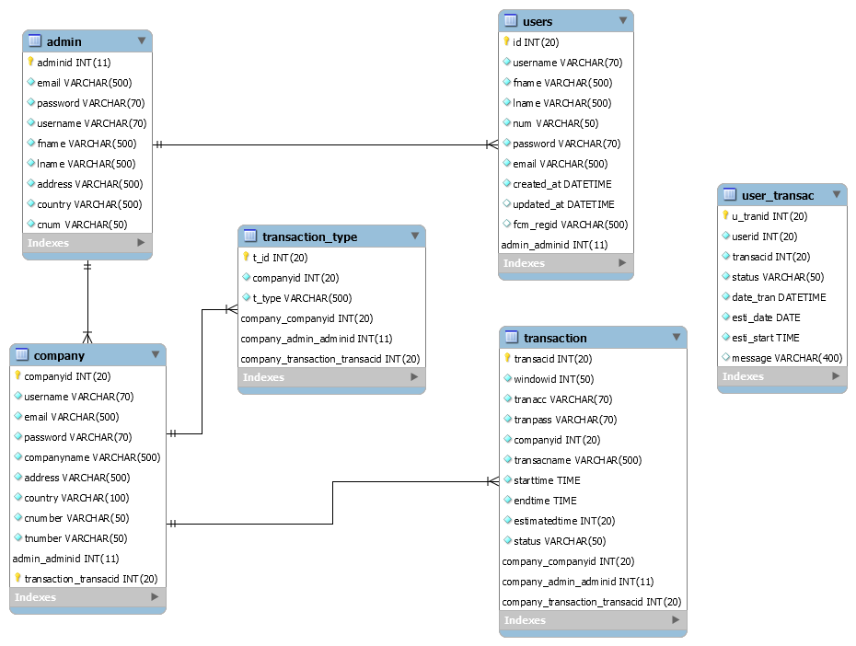The Entity Relationship Diagram shows the graphical presentations of entities of the database and their relationships. It shows how the data are shared between entities.­

*Figure 9.* Entity Relationship Diagram of the System

Figure 9 shows the relationship of the following entities from the database. The diagram shows that there are 4 modules in the system. Every company and user can only have one account. The admin manages the accounts of the company and the users while the company manages the transactions and transaction types. The user can transact to any transaction many times.

**Project Development**

**REQUIREMENT ANALYSIS**

**SYSTEM DESIGN**

**IMPLEMENTATION**

**DEPLOYMENT**

**TESTING**

**MAINTENANCE**

*Figure 10****.*** Waterfall Diagram

In Figure 10 using waterfall model is the best way to deliver the phases to be done in the study. The first phase in the process is gathering requirement and analysis, all the possible requirements of the system are elicited of the researchers by accumulating of data supports to the project. So, all the requirements are analyzed and documented in this phase that it is supposed to be in the system and to make sure that the requirements are unambiguous. Following the first phase is the system design, wherein the researchers compiled and interpret all the gathered information such as hardware and software system requirements. With this phase it produces and assists the researchers in the task of designing the overall system architecture. Now, the system design is complete, then it is the start of implementation and objective is based on it. The developers look at the system specification and created the software including the implementation of interfaces. The Android-Based Queuing System using QR Code was developed using HTML, CSS, Java Script as frontend and PHP and MySQL for the back-end of the website, also the mobile application for the customer was developed through the Android Studio.

Fulfilling all the objective in the project resulted to the next phase which is the testing of the study. The entire system is tested for any faults and failures. Succeeding to test of the study is the deployment, it is deployed in the customer environment or released to the market. Finally, maintenance is made to deliver some changes or further enhancement in the customer environment and issues may come up, so patches are released to fix it.

The algorithms of the android application that will be developed will be coded using the following steps:

1. Plan and design the desired user interface of system activities.
2. Create the activities and order it based on its function.
3. Create a database using web hosted phpMyAdmin.
4. Application Modules
   1. Splash Screen
      1. Create a Splash Screen activity that would notify the user that the application is in the process of loading.
   2. Login
      1. Create the function of the Login button that will send data about the username and password of the user and will redirect to Profile.
   3. Register
      1. Create the function of Register button that would send data about the information of the user and will redirect to Login.
   4. Profile
      1. Create the functions of buttons present such as Make Transaction, Manage Transaction, and will display the information of the user.
   5. Menu
      1. Create the functions of buttons present such as Settings, Logout, and Profile.
   6. Manage Transaction
      1. Create the function of Past Transaction button that would retrieve data about the past transactions of the user and the Pending Transaction button that would retrieve data about the pending transaction of the user.
   7. Pending Transaction
      1. Create the function of a button that would retrieve data about the transaction of the user and will display the generated QR code.
   8. Past Transaction
      1. Create the function of a button that would retrieve data about the transaction of the user and will display the generated QR code.
   9. Make Transaction
      1. Create the function of list of buttons that has the company’s name that would send data about the information of the company.
   10. Company
       1. Create the function of list of buttons that has the available transaction of the company that would send data about information of the transaction.
   11. Confirm Transaction
       1. Create the function of a spinner that would retrieve data of available schedules and Confirm button that would send data about the chosen transaction and schedule of the user.
   12. Notification
       1. Create the function of displaying the notification message 1 hour before, 2 minutes before and if it is now the user's turn.
   13. Window Notification
       1. Create the function of displaying the notification message if the window is already available or open as well as creating reply buttons, can’t go and can go.
   14. Logout
       1. Create the function to logout the customer’s account.
   15. Setting
       1. Create the function to update the user’s information.

Table 1.

*Use Case Title and Description*

|  |  |  |
| --- | --- | --- |
| **Use Case Number** | **Use Case Title** | **Use Case Description** |
| UC01 | Internet Connection | This use case will allow the user to use the application. |
| UC02 | Splash Screen | This use case will be displayed when the user start the application. |
| UC03 | Login | This use case will allow the user to input the user’s username and password. |
| UC04 | Register | This use case will allow the user to input the user’s information needed to make an account. |
| UC05 | Profile | This use case will display the information of the user and will allow the user to view its transactions and to make a transaction. |
| UC06 | Manage Transaction | This use case will allow the user to view its past transactions or pending transactions. |
| UC07 | Past Transaction | This use case will allow the user to view its past transactions and as well as the generated QR code. |
| UC08 | Pending Transaction | This use case will allow the user to view its pending transactions and as well as the generated QR code. |
| UC09 | Make Transaction | This use case will display a list of companies |
| UC010 | Company | This use case will display the information of the company and will show list of all available transactions |
| UC11 | Confirm Transaction | This use case will allow user to see the information of the transaction and the user will be able to choose the schedule for the user’s transaction. |
| UC12 | Notification | This use case will notify the user 1 hour before, 2 minutes before and if it is now the user’s turn. |
| UC13 | Window Notification | This use case will notify the user if the window is already available or open. |
| UC14 | Logout | This use case will allow the user to logout its account. |
| UC15 | Setting | This use case will allow the user to update the user’s information |

Table 1 shows the Use Case Title and Description which presents all the options and menus that would be seen in the application such as Internet Connection, Splash Screen, Login, Register, Profile, Manage Transaction, Past Transaction, Pending Transaction, Make Transaction, Company, Confirm Transaction, Notification, Window Notification, Logout and Setting. The table also gave the description and the function for each menu and option existing in the application.

**Operation and Testing Procedure**

**Operation Procedure**

For the operation procedure of the web application, the following are the steps to follow:

1. Install WAMPServer.
2. Open and run the web servers.
3. Copy the program files of web application.
4. Open and access the web application.

For the operation procedure of the android application, the following are the steps to follow:

1. Copy the installer of the application.
2. Install the application.
3. Connect to an internet connection.
4. Open and access the android application.

**Testing Procedure**

Table 2.

*Functionality, Portability and Usability: Test of the developed system*

|  |  |
| --- | --- |
| **Module** | **Steps Undertaken** |
| Administrator | 1. Login using the administrator username and password. 2. View dashboard 3. View list of companies 4. View information of company and its available transactions 5. View list of customers 6. View information of customer and its transactions 7. Update account |
| Company | 1. Login using username and preferred password 2. View dashboard 3. View list of type of transactions 4. Add or delete type of transaction 5. View list of transactions’ accounts 6. Add, update or delete transaction’s account 7. View list of customers 8. Update account |
| Window | 1. View dashboard 2. Scan a QR code 3. Mark a transaction “Done” 4. View list of customers 5. Notify customer 6. Close all transaction |
| Customer | 1. Login using username and preferred password 2. View Profile 3. Manage transaction 4. View past transaction and view generated QR code 5. View pending transaction and view generated QR code 6. Make transaction 7. Choose company 8. View company’s information and its available transactions 9. Choose transaction 10. View transaction’s information and choose schedule 11. Update account |

**Evaluation Procedure**

The system will be evaluated by 50 respondents composed of 10 IT professionals and 40 students of the Technological University of the Philippines-Manila using random sampling.

The evaluation procedure will be conducted as follows:

1. The system will be demonstrated by the researcher.
2. The evaluators will be asked to rate the performance of the system.
3. Each respondent will be given a set of questionnaires.
4. The system will be carefully evaluated by the respondents and they will be allowed to raise questions.
5. The respondents will be requested to rate the system based on the criteria in the evaluation instrument.
6. The results will be tallied to determine the mean of each criterion and the overall mean.
7. The results will be interpreted using Table 3.

**Evaluation Instrument**

The criteria for evaluation will be focused on the project’s functionality, efficiency, compatibility, usability, reliability, security, maintainability, and portability based on ISO 25010 criteria.

The evaluation instrument that will be used is a 4-point Likert Scale that will be shown in Appendix A. Likert Scale is a psychometric scale commonly use to questionnaires and is most widely used to survey research. By using the scale, the researcher can determine the acceptability of the project based on experience and user’s opinion of the acceptability of the system.

**Statistical Tool**

The statistical frequency was computed by getting the number of respondents to the given criteria. The total number of percentage was computed using the formula below and interpreted using the Numerical Rating in table 4.

Formula:

% = $\left(\frac{f}{n}\right)$ x 100

Where:

% = represents the percentage

f = represents the number of times the scores repeated in a set

n = represents the number of respondents

Table 3.

*Rating Scale for the Evaluation Instrument*

|  |  |
| --- | --- |
| **Numerical Rating** | **Qualitative Interpretation** |
| 4 | Highly Acceptable |
| 3 | Very Acceptable |
| 2 | Acceptable |
| 1 | Not Acceptable |

Table 3 describes the criteria and indicators of the evaluation instrument to measure the acceptability of the system.

Table 4.

*Scale Range and its Qualitative Interpretation*

|  |  |
| --- | --- |
| **Range** | **Qualitative Interpretation** |
| 76% - 100% | Highly Acceptable |
| 51% - 75% | Very Acceptable |
| 26% - 50% | Acceptable |
| 0% - 25% | Not Acceptable |

Table 4 describes the range scale of criteria and indicators of the evaluation instrument to measure the acceptability of the system.